

  - College of Computing and Data Science
  - Nanyang Technological University

SC3020 Database System Principles

Project 1

  - AY 25/26 Semester 2 | Group 20

Name | Email | Matriculation Number
Caleb Yeo |  | U232xxxxx
Gay Ming Kai | C230114@e.ntu.edu.sg | U2320596C
Lim Zu Liang |  | U232xxxxx
Lin Hongchao |  | U232xxxxx
Wang Siwen |  | U232xxxxx

1. Introduction
This project focuses on

2. Setup
This project uses PostgreSQL as instructed by the project description. However, we used docker to ensure that all of us have the same version control

3. Tasks

3.1. Disk Storage

3.1.1. Task 1: Block Size
Task Description
Methodology
The task was carried out through running the query show block_size; on the pgAdmin4’s SQL querying interface.
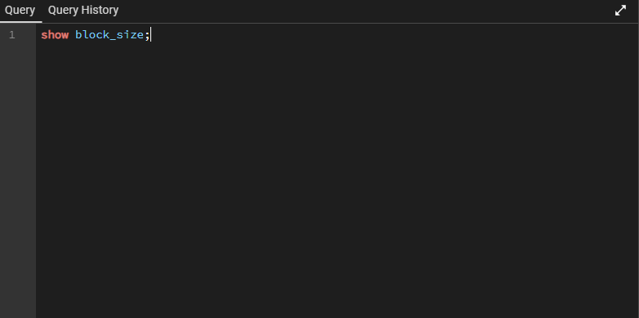
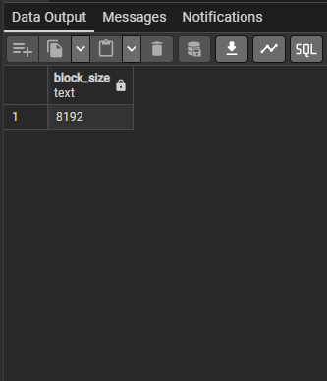
Screenshot
Explanation
Block size is 8192 bytes (8 kB) as it is the default block size of Postgres which is compiled into the server binary during installation which is set via BLCKSZ. Research have shown that it is possible to increase the maximum to 32 kB if necessary, however this would require a full data restore.

3.1.2. Task 1: Block Size
Task Description
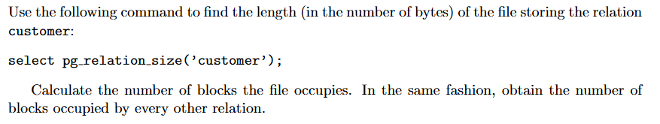
Screenshot
Explanation

